Granger predictability: GBPUSD and USDJPY
Method 13 / daily log returns / p=1 and p=5 / Alpari D1 full available history

Study setup
Logical pair: GBPUSD , USDJPY
Broker symbols: GBPUSD_i , USDJPY_i
Snapshot: 2026-11-03_majors_alpari_D1
Timeframe: D1
Matched return window: 1999-01-05 to 2026-11-02 (UTC bar dates)
Matched return count n: 7200
Dropped unfinished last bar dated 2026-11-03 UTC after a tick-volume check against the prior complete day.
Lag orders pre-specified: p=1 and p=5; both directions
Headline: p=5 joint F test in both directions
Complete matched rows (Excel): GBPUSD-USDJPY_Granger_D1.xlsx
Complete matched rows (HTML table): GBPUSD-USDJPY_Granger_D1_data.html

Method carried forward
Granger predictability asks whether lagged X helps explain Y beyond lags of Y alone on matched daily log returns of close, ln(close_t / close_t-1). Quotes are not inverted. For lag order p, the unrestricted model is y_t on an intercept, y_{t-1}..y_{t-p}, and x_{t-1}..x_{t-p}. The restricted model drops the x lags. The test is an F comparison of residual sums of squares via OLS (numpy.linalg.lstsq) and scipy.stats.f. Orders p=1 and p=5 are pre-specified; both directions are tested. The headline is the p=5 joint test in both directions. p=1 is reported beside it because the guide formula is the one-lag regression. Rejecting H0 is statistical predictability in mean in this sample; it is not economic causation and not a trading signal. There are 56 directed tests at p=5 across the 28 pairs.

Results
direction | p_lags | n | f_stat | p_value | b | df1 | df2
GBPUSD_to_USDJPY | 1 | 7199 | 1.2824185 | 0.25748756 | -0.01496169 | 1 | 7196
GBPUSD_to_USDJPY | 5 | 7195 | 0.85124824 | 0.51319547 | nan | 5 | 7184
USDJPY_to_GBPUSD | 1 | 7199 | 12.316106 | 0.00045181 | 0.03836868 | 1 | 7196
USDJPY_to_GBPUSD | 5 | 7195 | 3.0640368 | 0.00912779 | nan | 5 | 7184

Conclusion
Headline p=5 joint tests for GBPUSD and USDJPY: GBPUSD->USDJPY F=0.8512 (p=0.513195); USDJPY->GBPUSD F=3.0640 (p=0.00912779); usable rows n=7195. One-lag slopes: b_GBPUSD->USDJPY=-0.0150 (F=1.2824, p=0.257488); b_USDJPY->GBPUSD=0.0384 (F=12.3161, p=0.000451813). Rejecting H0 is in-sample mean predictability, not economic cause and not a trading signal.

Charts
Daily closes

Daily log returns

Granger F statistics
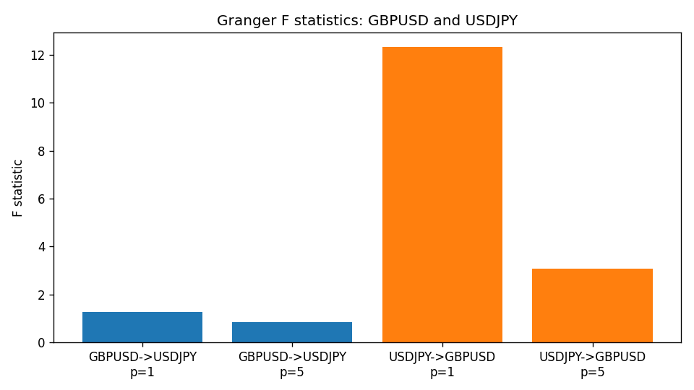

Data report
Every matched row is stored in the sibling Excel workbook named GBPUSD-USDJPY_Granger_D1.xlsx (sheet matched_rows). The results sheet holds the four F tests. Embedding all rows as a Word table is impractical; the Word file holds column summaries and the first and last 15 rows.
Columns: time, GBPUSD_open, USDJPY_open, GBPUSD_high, USDJPY_high, GBPUSD_low, USDJPY_low, GBPUSD_close, USDJPY_close, GBPUSD_tick_volume, USDJPY_tick_volume, GBPUSD_spread, USDJPY_spread, GBPUSD_real_volume, USDJPY_real_volume, GBPUSD_log_return, USDJPY_log_return
Column summaries (matched calculation rows)
column | count | mean | std | min | 25% | 50% | 75% | max
GBPUSD_open | 7200 | 1.5159933 | 0.21821503 | 1.06854 | 1.3249725 | 1.51133 | 1.63163 | 2.1066
USDJPY_open | 7200 | 113.81122 | 19.205564 | 75.693 | 104.42925 | 110.991 | 120.69125 | 163.824
GBPUSD_high | 7200 | 1.5222906 | 0.21878569 | 1.08366 | 1.329785 | 1.518035 | 1.638315 | 2.1161
USDJPY_high | 7200 | 114.30876 | 19.267108 | 76.001 | 104.8815 | 111.4435 | 121.26 | 163.978
GBPUSD_low | 7200 | 1.5096683 | 0.2174426 | 1.03518 | 1.319445 | 1.50319 | 1.6243 | 2.0983
USDJPY_low | 7200 | 113.28793 | 19.133561 | 75.402 | 103.89 | 110.5305 | 120.17 | 163.628
GBPUSD_close | 7200 | 1.5160611 | 0.21817876 | 1.06879 | 1.3250775 | 1.511235 | 1.63193 | 2.1065
USDJPY_close | 7200 | 113.82409 | 19.220954 | 75.811 | 104.42 | 111.028 | 120.6855 | 163.851
GBPUSD_tick_volume | 7200 | 94838.03 | 153554.65 | 62 | 10001.75 | 52905.5 | 91812.25 | 1273370
USDJPY_tick_volume | 7200 | 106136.9 | 179308.31 | 149 | 9925 | 53095 | 92761 | 1803508
GBPUSD_spread | 7200 | 26.967917 | 19.192953 | 0 | 11 | 20 | 50 | 50
USDJPY_spread | 7200 | 20.325556 | 17.633971 | 0 | 6 | 11 | 30 | 50
GBPUSD_real_volume | 7200 | 3.5565837e+09 | 8.4444068e+10 | 0 | 0 | 0 | 0 | 2.4038164e+12
USDJPY_real_volume | 7200 | 3.470121e+10 | 1.6077679e+11 | 0 | 0 | 0 | 0 | 3.8834203e+12
GBPUSD_log_return | 7200 | -2.396e-05 | 0.00564572 | -0.08388241 | -0.0031301 | 3.232e-05 | 0.00317911 | 0.03112653
USDJPY_log_return | 7200 | 4.769e-05 | 0.00620489 | -0.03908203 | -0.00320192 | 0.00011421 | 0.00340709 | 0.05184024
First 15 matched rows (selected columns)
time | GBPUSD_close | USDJPY_close | GBPUSD_log_return | USDJPY_log_return
1999-01-05 | 1.6547 | 111.92 | -0.0028966287 | -0.00017868311
1999-01-06 | 1.6537 | 112.77 | -0.00060452184 | 0.0075660159
1999-01-07 | 1.6502 | 111.33 | -0.002118709 | -0.012851583
1999-01-08 | 1.6405 | 110.8 | -0.0058954193 | -0.0047719894
1999-01-11 | 1.6312 | 109.02 | -0.0056851331 | -0.016195423
1999-01-12 | 1.6349 | 112.6 | 0.0022657001 | 0.032310364
1999-01-13 | 1.6499 | 113.52 | 0.0091330396 | 0.0081373171
1999-01-14 | 1.6531 | 113.52 | 0.0019376331 | 0
1999-01-15 | 1.6502 | 114.15 | -0.0017558204 | 0.0055343401
1999-01-18 | 1.6522 | 114.16 | 0.0012112405 | 8.7600193e-05
1999-01-19 | 1.6553 | 113.52 | 0.0018745281 | -0.0056219403
1999-01-20 | 1.6472 | 112.91 | -0.0049053846 | -0.0053879917
1999-01-21 | 1.6524 | 113.87 | 0.0031518998 | 0.0084664056
1999-01-22 | 1.6565 | 114.56 | 0.0024781662 | 0.0060412564
1999-01-25 | 1.6585 | 113.72 | 0.0012066366 | -0.0073594164
Last 15 matched rows (selected columns)
time | GBPUSD_close | USDJPY_close | GBPUSD_log_return | USDJPY_log_return
2026-10-13 | 1.32534 | 158.305 | 0.0036434319 | -0.0018932826
2026-10-14 | 1.31884 | 158.317 | -0.0049164679 | 7.5800166e-05
2026-10-15 | 1.32757 | 158.024 | 0.0065976411 | -0.0018524319
2026-10-16 | 1.33257 | 157.964 | 0.0037592051 | -0.00037976126
2026-10-19 | 1.33024 | 158.517 | -0.0017500314 | 0.0034946841
2026-10-20 | 1.3377 | 158.16 | 0.0055923442 | -0.0022546642
2026-10-21 | 1.33937 | 158.108 | 0.0012476328 | -0.00032883504
2026-10-22 | 1.33967 | 156.755 | 0.00022396082 | -0.0085942669
2026-10-23 | 1.33684 | 156.81 | -0.0021146949 | 0.00035080446
2026-10-26 | 1.33359 | 157.458 | -0.0024340661 | 0.0041238746
2026-10-27 | 1.33044 | 157.894 | -0.0023648393 | 0.0027651658
2026-10-28 | 1.33254 | 157.743 | 0.0015771808 | -0.00095679538
2026-10-29 | 1.33733 | 157.683 | 0.0035881935 | -0.00038043789
2026-10-30 | 1.33913 | 157.516 | 0.0013450605 | -0.0010596481
2026-11-02 | 1.3406 | 157.933 | 0.0010971256 | 0.0026438521

